**1.write a java program to print “ Hello World” to the console.**

**Code:**

**package** Lab1Programs;

**public** **class** HelloWorld {

**public** **static** **void** main(String[] args) {

// **TODO** Auto-generated method stub

System.***out***.println("Hello world");

}

}

**Output:**

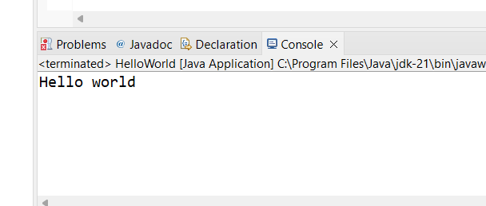

**2. Write a program to find the sum of two numbers entered by the user.**

**Code:**

**package** sumoftwonumber;

**import** java.util.Scanner;

**public** **class** SunOfTwoNumbers {

**public** **static** **void** main(String[] args) {

Scanner scanner = **new** Scanner(System.***in***);

System.***out***.print("Enter the first number: ");

**int** num1 = scanner.nextInt();

System.***out***.print("Enter the second number: ");

**int** num2 = scanner.nextInt();

**int** sum = num1 + num2;

System.***out***.println("The sum of " + num1 + " and " + num2 + " is " + sum);

}

}

**Output:**

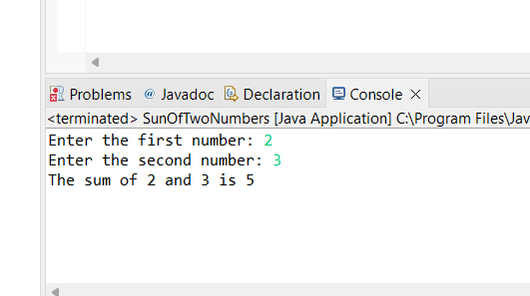

**3. Write a Java program to check whether a given number is even or odd.**

**Code**:

**package** Lab1;

**import** java.util.Scanner;

**public** **class** lab1 {

**public** **static** **void** main(String[] args) {

Scanner scanner = **new** Scanner(System.***in***);

System.***out***.print("Enter a number: ");

**int** number = scanner.nextInt();

**if** (number % 2 == 0) {

System.***out***.println(number + " is even.");

} **else** {

System.***out***.println(number + " is odd.");

}

scanner.close();

}

}

**Output:**

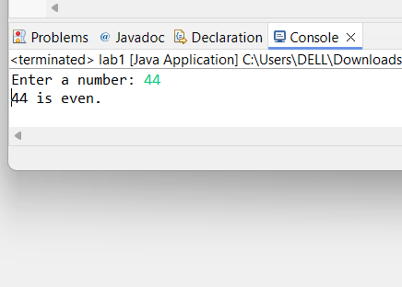

**4.Write a java program to find greatest of 2 numbers.**

**Code:**

**package** GreatestOfTwoNumbers;

**import** java.util.Scanner;

**public** **class** GreatestOfTwoNumber {

**public** **static** **void** main(String[] args) {

Scanner scanner = **new** Scanner(System.***in***);

System.***out***.print("Enter the first number: ");

**int** num1 = scanner.nextInt();

System.***out***.print("Enter the second number: ");

**int** num2 = scanner.nextInt();

**int** greatest = (num1 > num2) ? num1 : num2;

System.***out***.println("The greatest number is " + greatest);

}

}

**Output:**

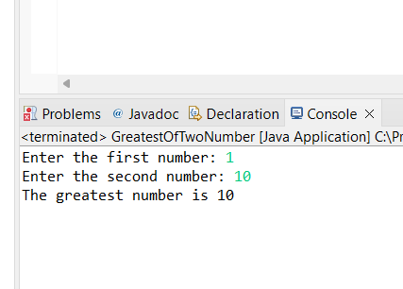

**5. Write a program to implement a basic calculator that takes input as a string expression & evaluates it.**

**Code:**

**package** Lab1Programs;

**import** java.util.Scanner;

**public** **class** BasicCalculator {

**public** **static** **void** main(String[] args) {

// **TODO** Auto-generated method stub

Scanner scanner = **new** Scanner(System.***in***);

System.***out***.print("Enter the first number: ");

**double** num1 = scanner.nextDouble();

System.***out***.print("Enter the second number: ");

**double** num2 = scanner.nextDouble();

System.***out***.print("Enter the operator (+, -, *, /): ");

**char** operator = scanner.next().charAt(0);

**double** result = 0;

**if** (operator == '+') {

result = num1 + num2;

} **else** **if** (operator == '-') {

result = num1 - num2;

} **else** **if** (operator == '*') {

result = num1 * num2;

} **else** **if** (operator == '/') {

result = num1 * num2;

}

System.***out***.println("result is : "+ result);

scanner.close();

}

}

**Output:**

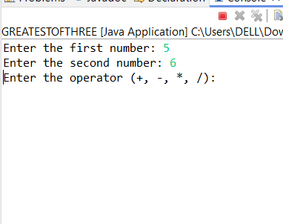

**6.Write a Java program to check if a given number is even or odd.**

**Code:**

**import java.util.Scanner;**

**public class EvenOrOdd {**

**public static void main(String[] args) {**

**Scanner scanner = new Scanner(System.in);**

**// Prompt the user to enter a number**

**System.out.println("Enter a number:");**

**int number = scanner.nextInt();**

**// Check if the number is even or odd**

**if (number % 2 == 0) {**

**System.out.println(number + " is even.");**

**} else {**

**System.out.println(number + " is odd.");**

**}**

**// Close the scanner to free up resources**

**scanner.close() }**

**}**

**Output:**

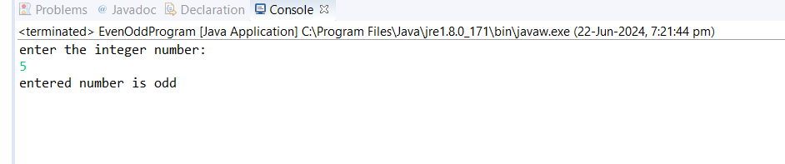

**7.Write a java program that compares two numbers & prints the larger one.**

**Code:**

**package** Lab1Programs;

**import** java.util.Scanner;

**public** **class** CompareNumbers {

**public** **static** **void** main(String[] args) {

// Create a Scanner

Scanner scanner = **new** Scanner(System.***in***);

System.***out***.println("Enter the first number:");

**int** number1 = scanner.nextInt(); // Read the first number and store it in variable number

System.***out***.println("Enter the second number:");

**int** number2 = scanner.nextInt();

// Compare the two numbers and print the larger one

**if** (number1 > number2) {

System.***out***.println("The larger number is: " + number1);

} **else** **if** (number2 > number1) {

System.***out***.println("The larger number is: " + number2);

} **else** {

System.***out***.println("Both numbers are equal.");

}

// Close the scanner

scanner.close();

}

}

**Output**

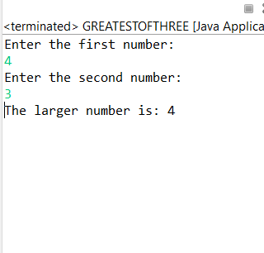

**8.Write a java program that take an age input from the user & determines if they are eligible to vote (considering the legal voting age.).**

**Code:**

**package** Lab1Programs;

**import** java.util.Scanner;

**public** **class** VotingEligibility {

**public** **static** **void** main(String[] args) {

// **TODO** Auto-generated method stub

Scanner scanner=**new** Scanner(System.***in***);

System.***out***.print("Enter the first number: ");

**int** age = scanner.nextInt();

**if** (age >= 18) {

System.***out***.print("You are eligible to vote.");

}**else** {

System.***out***.print("You are not eligible to vote.");

}

scanner.close();

}

}

Output:

OUTPUT:-

